## * Room Reservation

Create a Web form (HTML5 + CSS3 + images) that looks and behaves like the screenshots below:

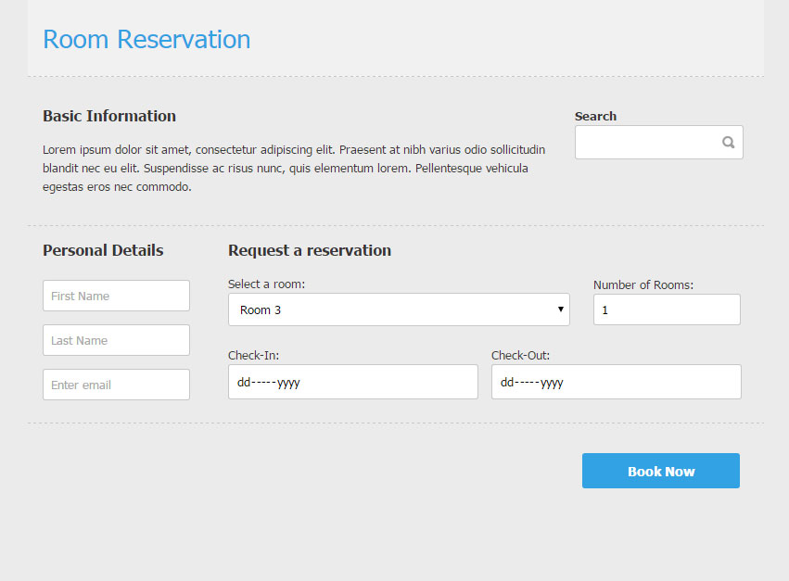

### Input

You are given the above screenshots and all required images.

### Output

The output should be valid HTML5 + CSS3 + images that implement the above Web form.

### Constraints

* Font: 13px Tahoma, Helvetica, sans-serif.
* Title: 28px; Subtitle: 16px; Tahoma, Helvetica, sans-serif.
* Content max-width: 800px;
* The icon in search field is a button.
* “Select a room” is drop-down.
* “Number of rooms” is number field.
* “Check-in” and “Check-out” are date fields.
* Other fields are text.
* Form validation is not required.
* The site should open correctly in Chrome 35.
* Responsive design is not required.
* Pixel-perfect implementation is not required.